Resources:
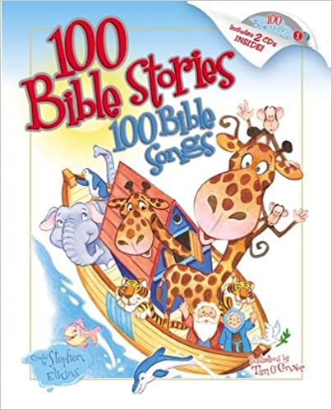
100 Bible Stories, 100 Bible Songs by Stephen Elkins

This book is used to read Bible stories with young children. Then used as a resource when characters and stories and talked about in our situations.

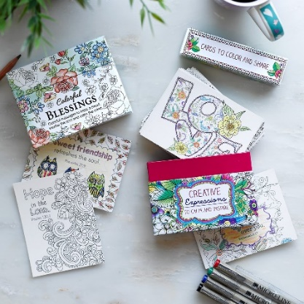
Creative Expression Cards Color and Share

These cute cards are purchased then color and gifted to family and friends to spread hope and love.

365 Read-Aloud Bedtime Bible Stories
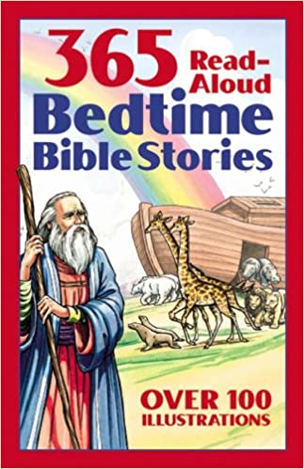
One idea that we did when the kids were in elementary school was to read 365 Read-Aloud Bedtime Bible Stories.
We would do it before bed and the kids would take turns reading the story for the day. The theory was to have the entire kids Bible read in a year.

Read and Share Bedtime Bible and Devotional
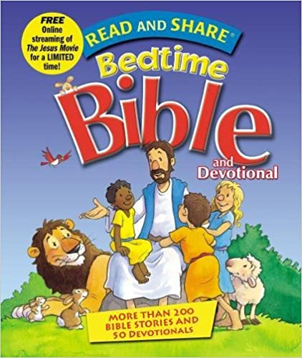
Another nice Bible for young children to read and interact with Bible stories.

Online Resources:
CathFamily.org
Catholicicing.com
Catholicmom.com
Teachingcatholickids.com
Apps for Phones:
The Bible App
Catholic Daily Readings
Laudate

